# **NEW OR REVISED COURSE PROPOSAL**

CENTRAL NEW MEXICO COMMUNITY COLLEGE

### MSE CURRICULUM COMMITTEE

**This is course is NEW / EXISTING**

|  |  |
| --- | --- |
| **Prefix, Number, and Course Title** | **CSCI 2720 Quantum Hardware** |
| **Discipline** | **Engineering Technology** |
| **Credit Hours and Type** | **4 credits (6 contact hours; 3 hours lectures, 3 hours lab)** |
| **Proposal Originator** | **Hyekyung Clark** |
| **Curriculum Liaison** |  |

## Proposal

**I. Description of New Course or Existing Course Change** (Include any additions, deletions, or modifications; address the impact on other schools’ offerings)

Request new HED course number.

**ENGT 2712 – Quantum Hardware**

**Course Description**:

An intermediate course that will create an understanding of quantum information system hardware, provide hands-on experience with quantum systems, and explore quantum phenomena. Students will learn about quantum superposition and entanglement, and how these phenomena can be used to create quantum bits (qubits) and gates. They will explore how measurements effect quantum systems. The students will get hands-on experience creating entangled pairs of single photons, trapping/exciting neural atoms, and quantum sensing.

Co-requisite: ENGT 2020 Laser and Photonics

Student Learning Outcomes

1. Describe and build apparatuses to demonstrate quantum phenomena of superposition and entanglement.
2. Describe the properties of a Qubit and differences between neutral atom, trapped ion, photonic, superconducting, and spin Qubits.
3. Demonstrate the ability to configure and tune a magneto-optical trap to create a Qubit and induce Rabi flopping.
4. Describe the principles of and demonstrate operation of a Diamond NV quantum sensor.
5. **Justification for the Addition/Change.** (Explain the reason for the addition/change; address the impact on current students.)

Part of the CSCI Quantum Technician certificate. This course will pre-align with CNM Ingenuity Quantum Technician program for CPL (credit for prior learning).

**IIa. For new courses:** List course prerequisites, or corequisites, or pre- or corequisites

Co-requisite: ENGT 2020 – Laser and Photonics

**Is this new course going to be offered every term? YES / NO**

**If this is a general education course, indicate which core area applies to the course:**

**n/a**

**If this is an Arts & Sciences course, indicate which core area applies to the course:**

**n/a**

**If this is a CTE course, indicate which core area applies to the course:**

**Engineering**

**Is this course repeatable for credit? If yes, indicate maximum credits and/or number of times course can be repeated. YES / NO**

**Will the course be delivered in person? YES / NO**

**Will the course be delivered online? YES / NO**

**Is this course currently part of the NM Common Course Numbering? YES / NO**

**Was this course developed specifically for transfer to a program(s) at a NM 4-year higher education public institution? YES / NO**

**If yes, list the institution(s), program(s), and suggested equivalent course(s):**

1. **Impact of the Change**

Consider the effects and consequences that the change might have on various stakeholders.

(a) YES or NO Will this change affect existing articulation agreements?

(**Please perform a search for all programs using the course**)

(b) YES or NO Will the change affect existing accreditations?

(c) YES or NO Will the change increase the need for additional facilities and/or equipment?

(d) YES or NO Will the change increase the need for additional faculty?

(e) YES or NO Will the change affect pre- or co-requisite considerations?

**(Please perform a search for all programs using the course)**

(f) YES or NO Will the change affect graduation requirements?

(g) YES or NO Will the change negatively affect continuing students?

(h) YES or NO Will the change increase the need for additional course offerings (sections)?

If you answer **Yes** to any item (*a through h*)*,* please use the space below to describe the effects and the actions you have taken to address them. Attach any additional paperwork and label the effects you are addressing with the letter indicating the impact you are addressing.

**IV. Course Attributes**

**Banner Attributes – highlight all that apply**

Arts & Sciences

Arts & Sciences Lab Science

Arts & Sciences Foreign Language

Arts & Sciences Literature

Capstone

Does not apply

**Does this course have work embedded learning attributes? If yes, indicate which.**

**V. Financial Aid Questions**

**Does this course fulfil a degree or certificate requirement? YES / NO**

**If yes, what degree or certificate?**

**Engineering Tech Certificate of Completion**

**Does this course have lab credit hours? YES / NO**

**Has this course been offered previously under a different name? YES / NO**

**If yes, what was the previous name of the course?**

**VI. Student Learning Outcomes**

**Please list the learning outcomes for this course.**

1. Describe and build apparatuses to demonstrate quantum phenomena of superposition and entanglement.
2. Describe the properties of a Qubit and differences between neutral atom, trapped ion, photonic, superconducting, and spin Qubits.
3. Demonstrate the ability to configure and tune a magneto-optical trap to create a Qubit and induce Rabi flopping.
4. Describe the principles of and demonstrate operation of a Diamond NV quantum sensor.

**Please submit a copy of the syllabus for this course along with this proposal.**

Draft - 15wk – Syllabus – CSCI Quantum Hardware

Pre-requisite: CSCI 2720 Quantum Hardware

# General Information

| General Information | Items |
| --- | --- |
| Instructor Name: |  |
| Email: |  |
| Office Location: |  |
| Office Phone: |  |
| Office Hours: |  |
| Course Number: |  |
| Section Number: |  |
| Semester & Year: |  |
| Credit Hours: |  |
| Campus/Rooms: |  |
| Meeting Time: |  |

## Course Description

An intermediate course that will create an understanding of quantum information system hardware, provide hands-on experience with quantum systems, and explore quantum phenomena. Students will learn about quantum superposition and entanglement, and how these phenomena can be used to create quantum bits (qubits) and gates. They will explore how measurements effect quantum systems. The students will get hands-on experience creating entangled pairs of single photons, trapping/exciting neural atoms, and quantum sensing.

## Required Materials

**No Required Textbook, all readings will be provided by instructor.**

## Course Student Learning Outcomes

1. Describe and build apparatuses to demonstrate quantum phenomena of superposition and entanglement.
2. Describe the properties of a Qubit and differences between neutral atom, trapped ion, photonic, superconducting, and spin Qubits.
3. Demonstrate the ability to configure and tune a magneto-optical trap to create a Qubit and induce Rabi flopping.
4. Describe the principles of and demonstrate operation of a Diamond NV quantum sensor.

## Assessments

## Schedule of Topics (tentative)

|  |  |  |
| --- | --- | --- |
| **Schedule** | **Instructional Unit (IU)** | **Science Practical Activities (SPA)** |
| Week 1 | Introduction to Quantum and basic linear algebra | Lab Safety |
| Week 2 | Superposition, Quantum Gates | Lab: Bloch Sphere |
| Weeks 3 | Entanglement | Lab: Bell’s Inequality |
| Weeks 3-4 | Particle/Wave Dual Nature of Light, Polarization, and Quantum Eraser | ThorLabs Quantum Eraser (1) |
| Weeks 5-6 | Quantum Measurements | ThorLabs Bomb Tester (2) |
| Week 7 | Cryogenics | Lab: Cryogenics |
| Week 8 | Superconducting and Spin Qubits | Lab: Spin |
| Weeks 9-10 | Laser Cooling | ThorLabs Optical Tweezer Kit (3) |
| Week 10 | Atomic, Molecular, and Optical Qubits | Lab: Photonics |
| Week 11-12 | Neutral Atom QIS Operations | Lab: QuLL Rb-85 MOT |
| Week 13-14 | Quantum Sensors: Diamond NV | Lab: QickDawg Quantum Microscope (4) |
| Week 15 | Conclusion | Lab: Practical System Design |

**NOTE: The ThorLabs Quantum Optics Kit (5) can be used in place of the Quantum Eraser and Bomb Test Demonstration Kits.**

1. ThorLabs Quantum Eraser

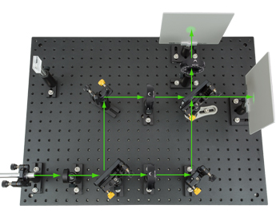

1. ThorLabs Bomb Tester

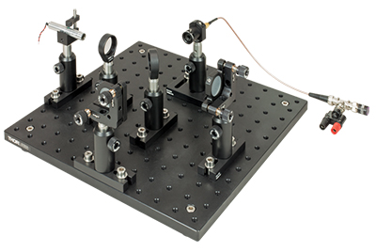

1. ThorLabs Optical Tweezers

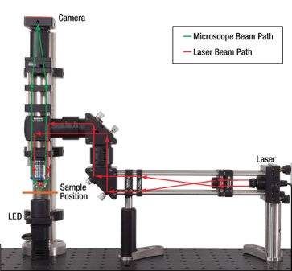

1. QickDawg Quantum Microscope

1. ThorLabs Quantum Optics Kit

